Lecture 16, October 14, 2010 (Key Points)

From Lumped towards Distributed Modeling: Width Function GIUH for a Physical Understanding of Flow Attenuation in Clark’s Hydrograph

16.1 A Brief Review of IUH and Convolution
An Instantaneous Unit Hydrograph (IUH) is a mathematical abstraction of the unit hydrograph concept introduced by Sherman in 1933. It represents the characteristic stream flow response at the outlet of a drainage basin to a spatially uniform effective rainfall input that is applied instantaneously on the basin. Let an IUH be denoted by the function, . To apply the IUH concept to effective rainfall of finite duration, , we assume that the total stream flow at time t>0 is the sum of individual responses from an effective rainfall of intensity, . At a fixed location, τ from the origin, the total rainfall in a very short time interval is given by, . Therefore, the flow at time t due to this input is . This idea is shown schematically in Fig. 16.1.
The assumption of superposition of individual outputs from inputs over very small intervals, as τ varies from 0 to , is called the assumption of linearity. It produces an expression for total flow as,
(16.1)
(16.2)
Eqs. (16.1) and (16.2) together are known as a convolution equation. Dooge (1973) has given extensive applications of convolution operation to rainfall-runoff modeling, and it is an excellent reference for a review of linear theory of hydrologic systems.
A variety of empirical and conceptual ideas were put forward during the 1950s and the 1960s that were designed to compute the IUH of a drainage basin. Both Dooge (1973) and Chow (1964, Ch. 14) are excellent references for this body of engineering hydrology literature. Brutsaert (2005, Ch. 12) gives a nice discussion of the linear theory of hydrologic systems, IUH and the convolution.

16.2 GIUH and a physical interpretation of Storage in Clark’s IUH

- Kirkby (1976) gave a physical interpretation of flow attenuation in terms of his GIUH formulation. It showed the importance of width function GIUH in making progress towards a physical understanding of distributed response of a basin, which is not apparent from the bulk parameter K in Clark’s IUH.

2. Kirkby defined a hillslope hydrograph, per unit length uniformly (in space) along all channel links. Then the stream discharge at the outlet is given by the convolution equation (Kirkby, 1976, eq. (19)):

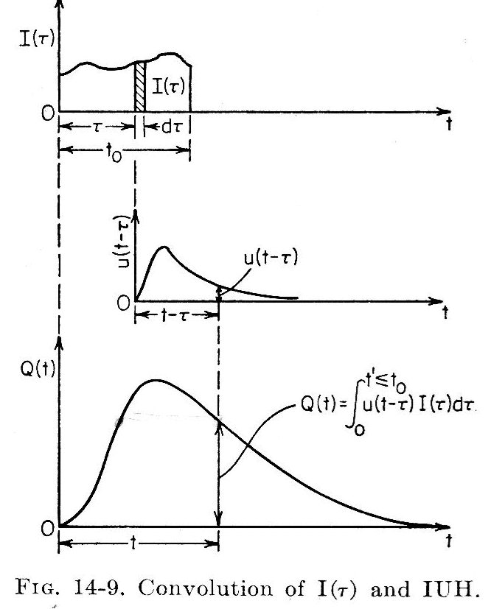

Figure 16.1 A schematic depiction of convolution operation (Chow, 1964, Ch. 14)

(16.3)

Here, is the geometric width function, and c(t) is the kinematic wave velocity that is assumed to be uniform in space after time t. For an in-depth discussion of kinematic wave approach for free surface flow, see Brutsaert (2005, Ch. 5, p. 190). The spatial uniformity approximation is based in the classic work of Leopold and Maddock and others on “ downstream hydraulic-geometry”, that we will cover later in this course.

3. We can simplify Eq. (16.3) by assuming that the flow velocity is a constant in time, and denote it by ν (Lecture 15),

(16.4)

You can also write Eq. (16.4) as follows because it is a convolution equation.

, (16.5)

- In order to compare Eq. (16.5) with Clark’s unit graph representation (Lecture 15), let denote the mean area of a hillslope draining into a channel link. Then, Eq. (16.5) can be written as,

(16.6)

The hillslope hydrograph has the units [1/T]. It is given by the expression,

(16.7)

5. The identification in Eq. (16.7) is an important step in developing a physical understanding of the ‘ad hoc and lumped’ storage term in Clark’s hydrograph. The concept of width function based GIUH, and the stream flow representation given in Eq. (16.6), make it possible to give it a physical interpretation. Eq. (16.6) also allows other forms of hillslope hydrographs to be incorporated in it, which are different from Clark’s.

16.3 The Challenge of Multi-scale Variability in Distributed RF-RO Processes

- Typical spatial scales of practical scientific and engineering interest for river basins span about four decades (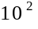-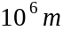), and temporal scales, hourly, daily, annual, decadal, centennial, millennial and even longer.

- A river basin can be naturally partitioned into a system of channel links and two attendant hillslopes draining into each link. There exists a substantial body of literature using DEMs to identify channel links and hillslopes. We have been using CUENCAS to visualize this decomposition of the terrain of a river basin, e.g., GCEW (Lecture 10).

- The scientific understanding of individual hydrologic processes at the laboratory scale on the order of is reasonably well developed. Hydrology textbooks cover physical processes in detail at this scale (Brutsaert, 2005).

- At the spatial scale of a single hillslope, on the order of , laboratory-scale spatial variability in hydrologic processes cannot be ignored. Besides soil heterogeneity, new elements begin to influence runoff generation, such as topography and vegetation. Laboratory-scale physical equations are being used to understand runoff-generation in a hillslope (Duffy, 1996; Lee, 2007). However, a comprehensive understanding of runoff generation for a single hillslope remains an unsolved problem (see Lecture 14).

- Beyond a single hillslope, spatial and temporal variability among multiple hillslopes dominates processes of runoff generation. See Fig. 9.1(c), Lecture 9. How to quantify runoff-generation on a large number of hillslopes remains unsolved. It is an important topic for future research.

- Chezy’s equation of open channel flow is written as,

(16.8)

Here, is channel velocity, C is the Chezy’s friction coefficient, S is the friction slope (assume that it is same as the bed slope), and R is the hydraulic radius given by the ratio of the x-sectional area of a channel to its the wetted perimeter. If is substituted into Eq. (16.8), where n is the Manning’s roughness coefficient, you get the Manning’s equation for channel velocity. These empirical equations are widely used in engineering practice.

- Kean and Smith (2005) developed a fluid-mechanical model that resolves boundary roughness elements from field measurements over a natural channel reach and calculated the cross-sectional averaged velocity to predict theoretical rating curve. They also predicted the widely used empirical Manning and Chezy friction parameters, and demonstrated that they are not constant as commonly assumed, but vary with flow depth. This body of work provides a scientific framework to specify velocity for a link.

- A river basin consists of multiple channel links. The geometry and dynamics of flow varies among these links. The classic work of Leopold and Maddock and others on “ at-a-station” (temporal) and “downstream” (spatial) “hydraulic-geometry” introduced these ideas in the literature in the 1950s. Mantilla (2007) addressed the problem of parameterizing hydraulic-geometry into flow dynamics in a river network for a RF-RO event, but this work is not published as yet.

- The hydrologic descriptions for sub basins larger than a hillslope-link pair consist of the space-time integrated behaviors of several hillslopes and channel links along a channel network at corresponding time scales. It is widely done in RF-RO models of engineering hydrology. You will see later that partitioning a basin into sub-watershed larger than hillslope-links on a terrain makes it nearly impossible to understand their behavior from laboratory scale equations. However, RF-RO models ‘get around this problem’ by calibrating (fitting) model parameters, which does not facilitate advances in understanding multi-scale complexity of RF-RO processes.
References:

Brutsaert, W. Hydrology: An Introduction, Cambridge, 2005.

Chow, V T. (Ed), Handbook of Applied Hydrology, 1964.

Dooge, J. C. I, Linear theory of hydrologic systems, Technical Bulletin 1468, Agriculture Research Service, US Department of Agriculture, Washington DC, 1973.

Duffy, C. A two state integral balance model for soil moisture and groundwater dynamics in complex terrain, Water Resour. Res., 32(8): 2421-2434, 1996.

Kean, J.W. and J.D. Smith, Generation and verification of theoretical rating curves in the Whitewater river basin, Kansas, J. Geophy. Res., 110, F04012, doi:10.1029/2004JF000250, 2005.

Kirkby, M.J. Tests of the random network model, and its application to basin hydrology, Earth Surf. Processes, 1, 197-212, 1976.

Lee, D. H. Testing a conceptual hillslope recession model based on the storage-discharge relationship with the Richard’s equation. Hydrol. Process. 21, 3155–3161, 2007.

Mantilla, R., Physical basis of statistical scaling in peak flows and stream flow hydrographs for topologic and spatially embedded random self-similar channel networks, Ph.D. thesis, University of Colorado, Boulder, CO, 2007.

